**REG NO. : 41242205009**

**NAME : AKASH RAJ L**

**SOURCE CODE :**

**image_mapping.html**

<!DOCTYPE html>

<html lang="en">

<head>

<meta charset="UTF-8">

<meta name="viewport" content="width=device-width, initial-scale=1.0">

<title>Image Map with External Links</title>

<style>

body {

font-family: Arial, sans-serif;

}

</style>

</head>

<body>

<h1>Interactive Image Map</h1>

<p>Click on the different parts of the image to visit external websites.</p>

<!-- Embed the image map -->

<img src="background.jpg" usemap="#image-map" alt="Interactive Image" style="max-width: 100%; height: auto;">

<map name="image-map">

<!-- Define the hot spots with external links -->

<area shape="rect" coords="34,44,270,350" alt="Google" href="https://www.google.com" target="_blank">

<area shape="circle" coords="337,300,44" alt="YouTube" href="https://www.youtube.com" target="_blank">

<area shape="poly" coords="290,172,333,250,325,185" alt="Wikipedia" href="https://www.wikipedia.org" target="_blank">

</map>

</body>

</html>

**OUTPUT :** 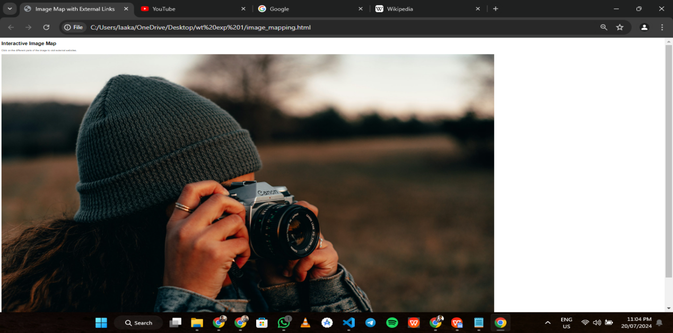

**HOTSPOT 1 : GOOGLE**

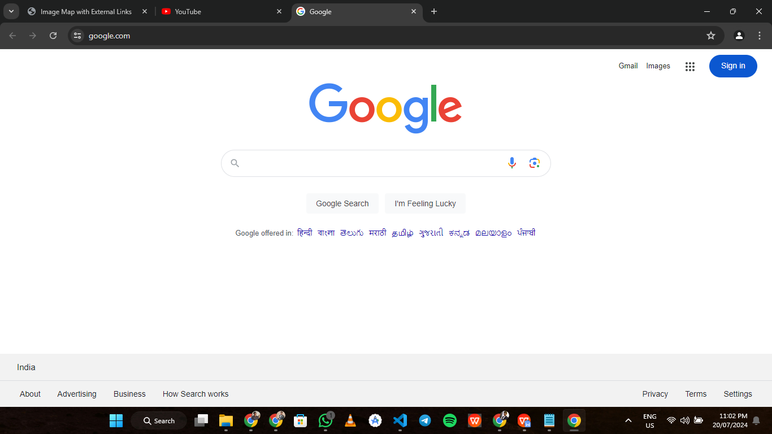

**HOTSPOT 2 : YOUTUBE**

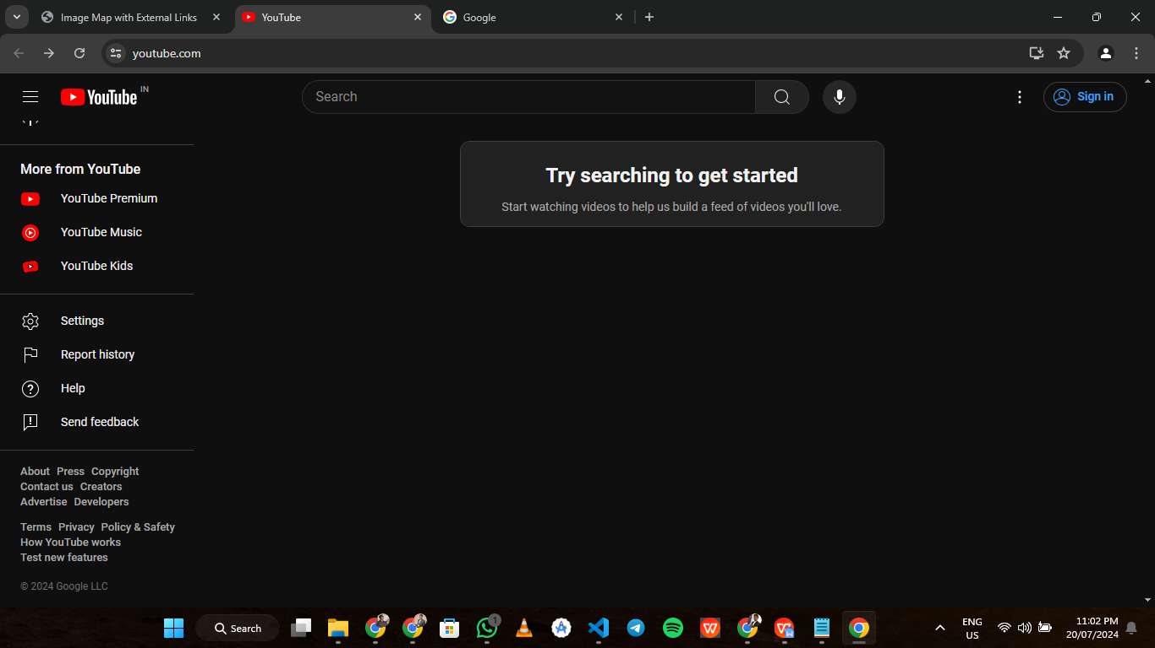

**HOTSPOT 3 : WIKIPEDIA**

